Human lives in the Old Stone Age |  | Difficulty
Human lives in the Old Stone Age |  |  | 1

Name︰_______________ （ ） Class︰__________

Historical skill | Describe features
Related Textbook Content | 1A pp. 8-9

Study the sources below and answer the following questions.

Source A
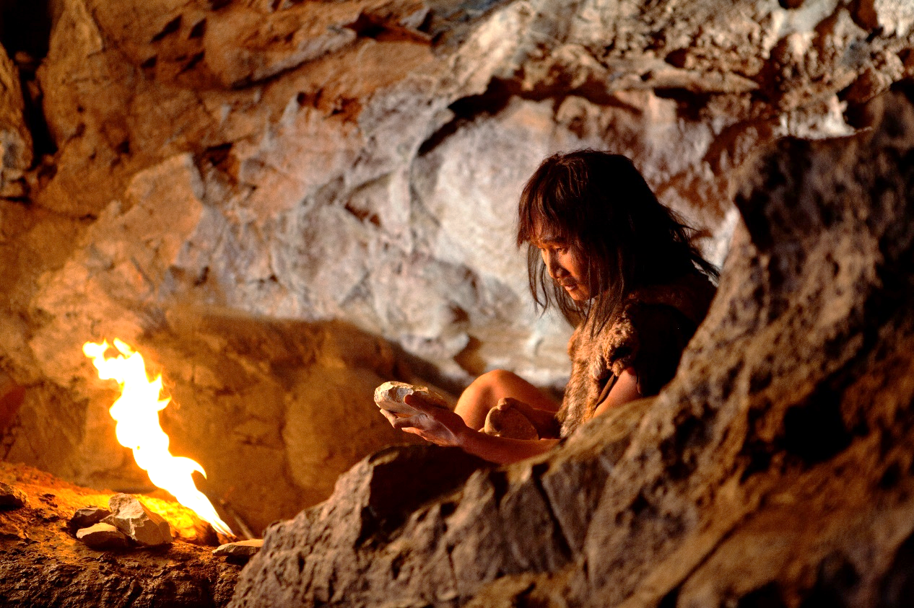

1. In which place did the person in Source A lived in? Identify source
The person in Source A lived in ________________.

2. In Source A, what did the person use fire for? (add ) Observe source
Light
Warmth
Cooking food
Driving away wild animals

3. As reflected in Source A, which material was used by humans to make tools? Understand source
Humans used ________________ to make tools.

4. Referring to the question above, based on your own knowledge, what did humans use these tools for? Give examples for description
________________________________________________________________________

Answers

1. The person in Source A lived in ______a cave______.

2.
Light
Warmth
Cooking food
Driving away wild animals

3. Humans used _______stones______ to make tools.

4. Humans used stone tools to hunt and for self-defence.

